**15CSE337 CLOUD COMPUTING AND SERVICES**

**Tutorials on AWS Lambda, API Gateway and RDS**

**NAME**: SRISHILESH P S

**ROLL NO.**: CB.EN.U4CSE17458

This is a simple tutorial which focuses on creating a sample HTML page, do the authentication in Lambda and storing in databases using AWS Lambda through API gateways to store in AWS RDS MySQL database.

The below HTML page accepts two numbers from the user and computes the Addition, Subtraction, Multiplication and Division. These values gets stored in MySQL database.

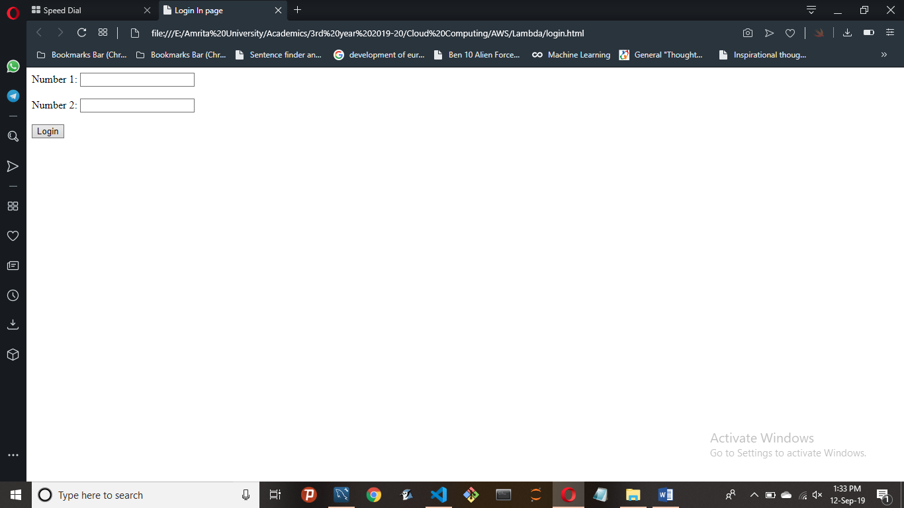

Like the Database shown below

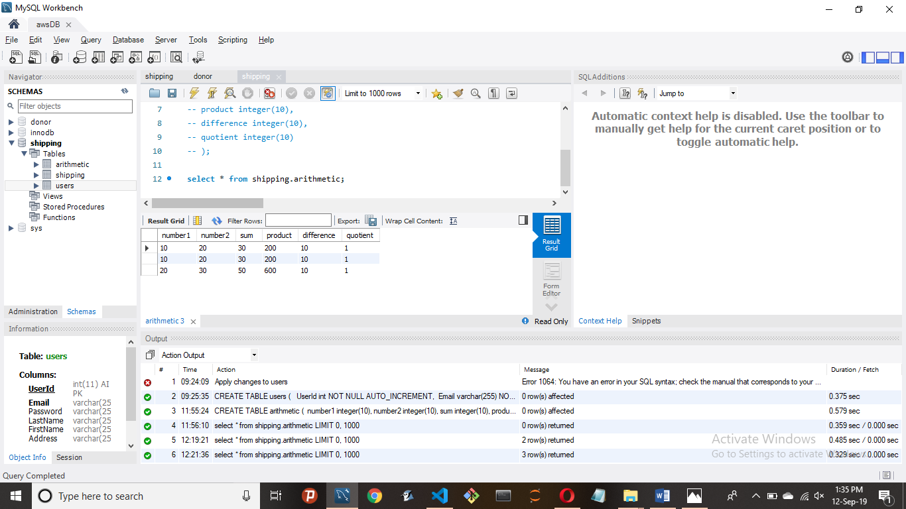

Follow the below steps

1. Create AWS Lambda function like the one shown below

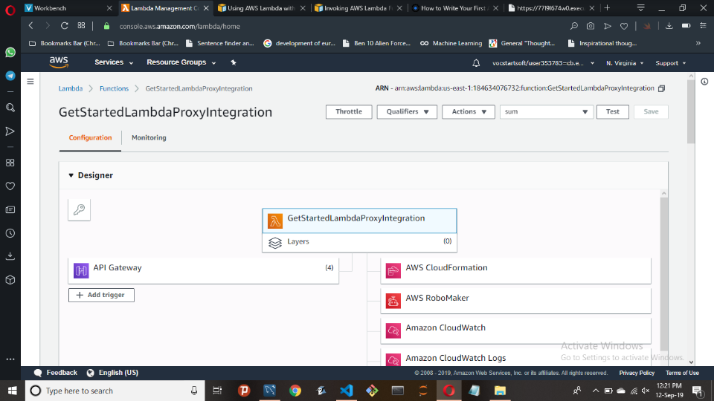

1. Complete your HTML code

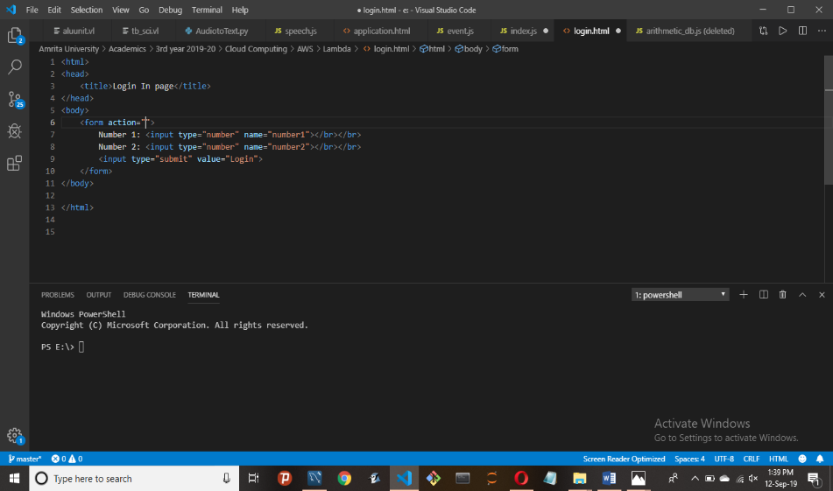

1. Write your code for the AWS RDS database connection and the AWS Lambda connection in *index.js*

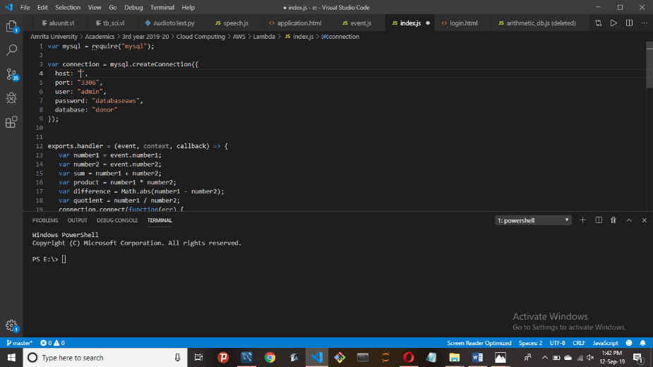

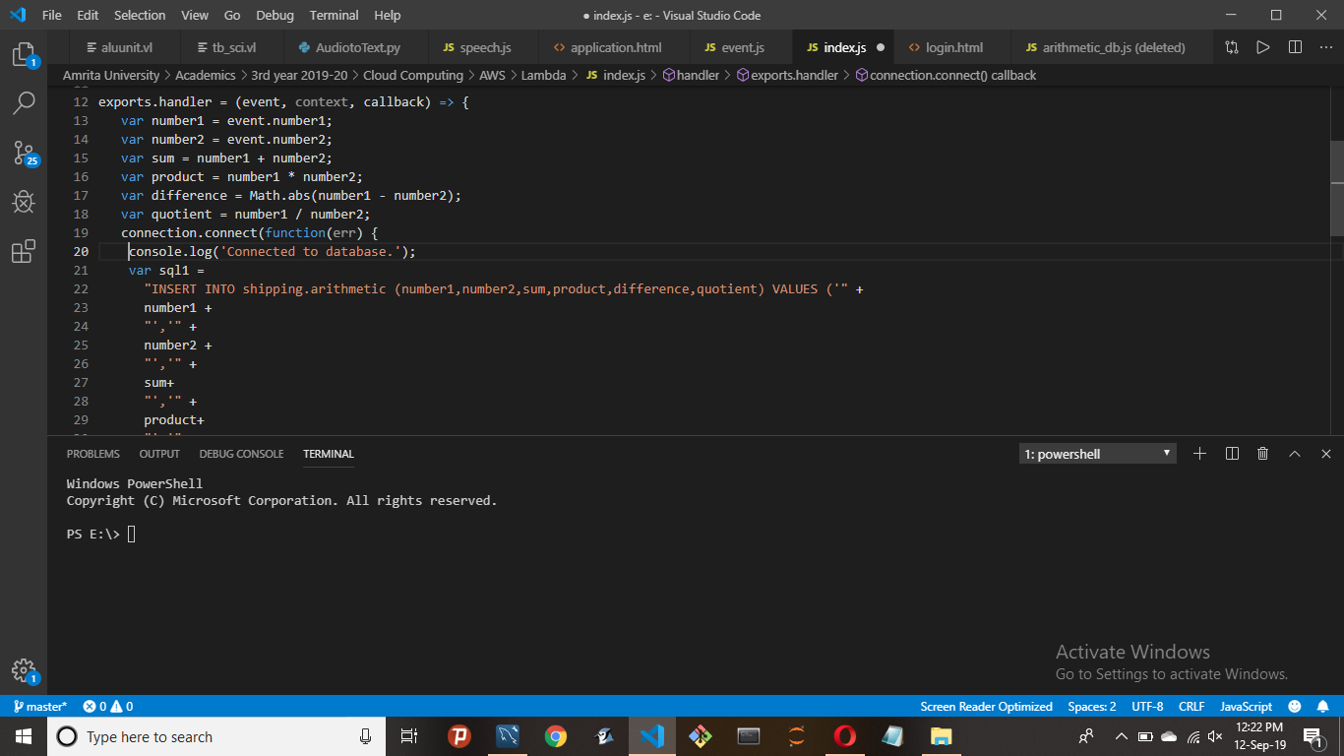

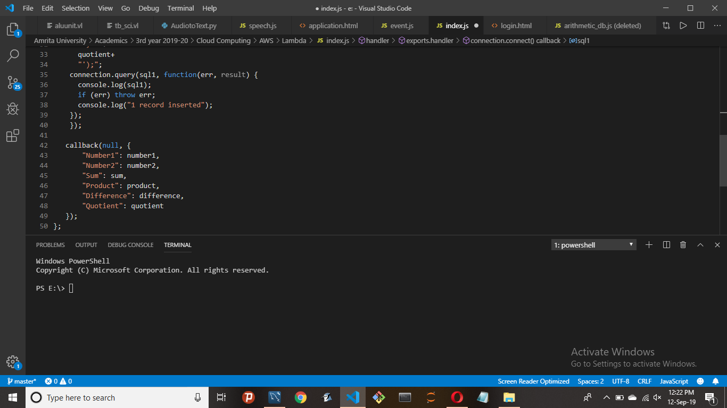

1. Next, compress the *node_modules, package.json, package_lock.json and index.js* into a compressed folder, and upload it as .zip file to AWS Lambda

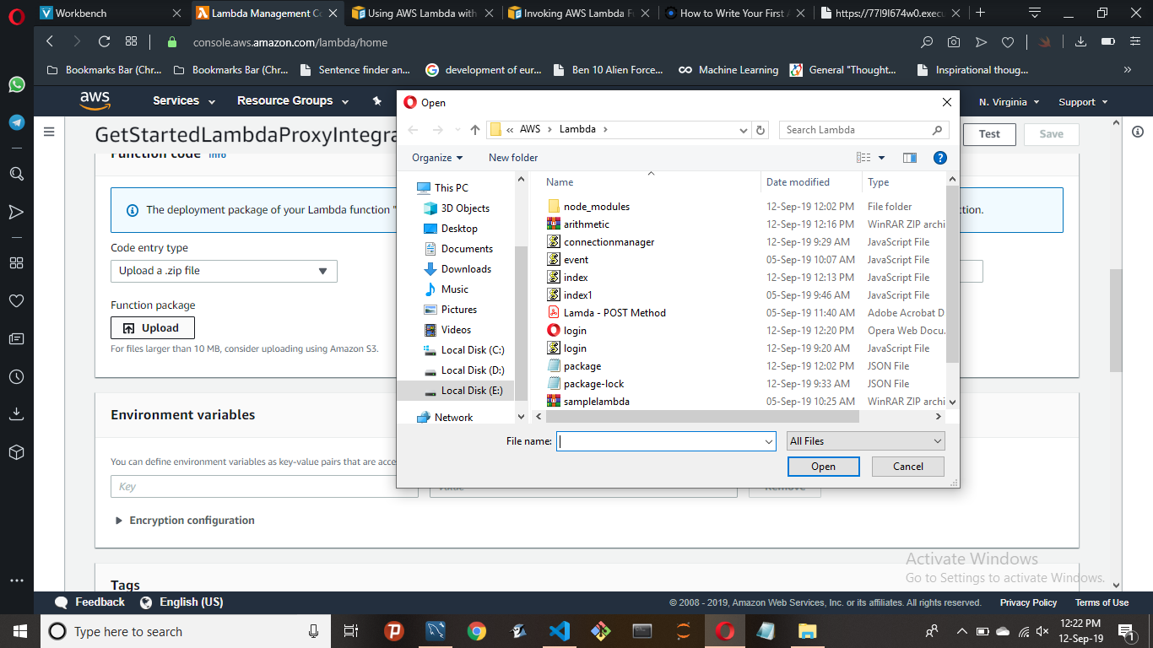

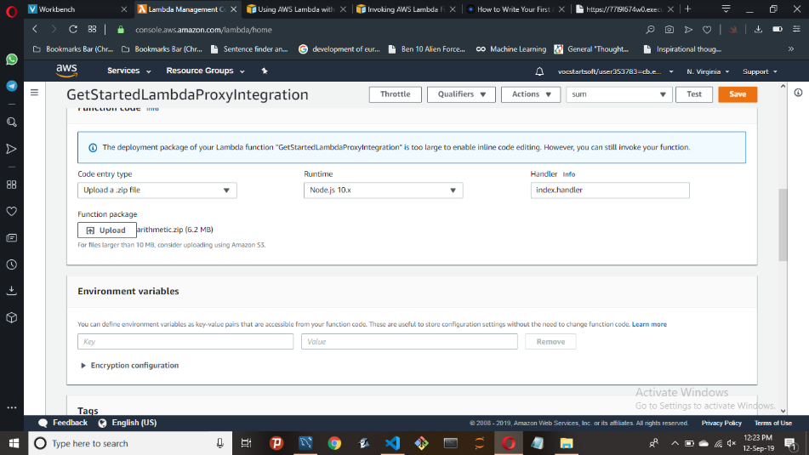

1. Later, save it and test it.
2. Now, go to API Gateway services and create a new API

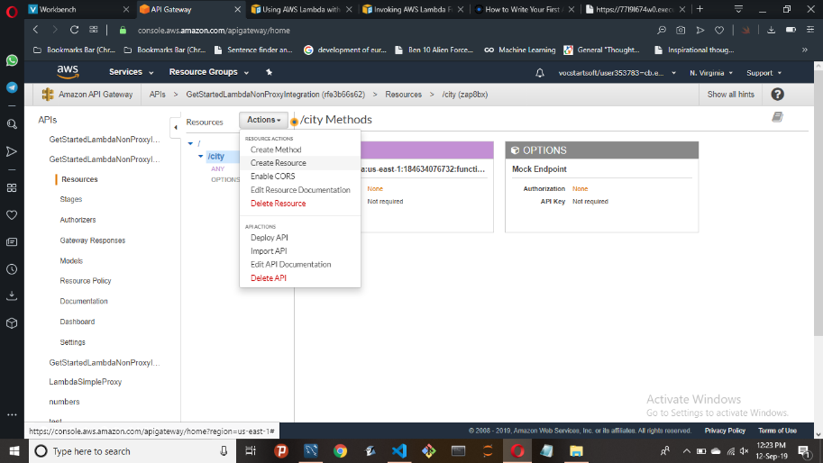

Create new **resource** and create new **method**. You must select the method type as **ANY**.

1. Now, select **Integration Request** in the methods tab, and head to **Mapping Templates**

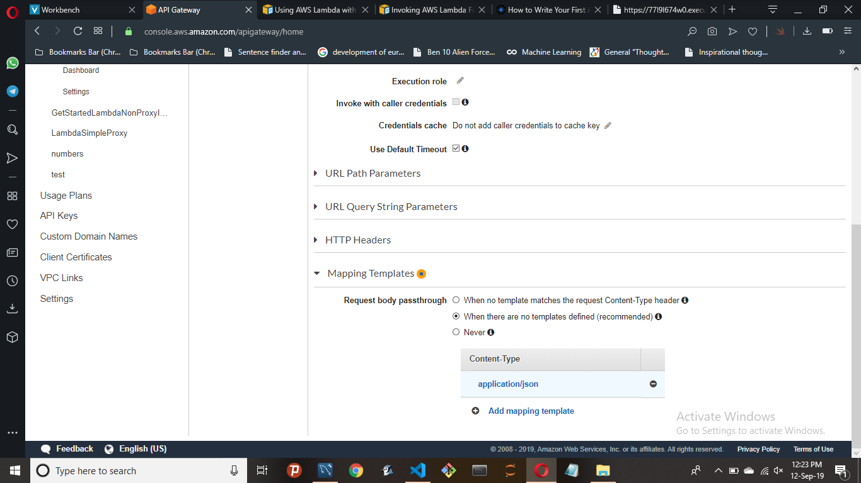

Type **application/json** as the content type, and type the below code in the template box

***{***

***“number1”:$input.params(“number1”),***

***“number2”:$input.params(“number2”)***

***}***

1. After completing the above steps, now it’s time to **Deploy API**

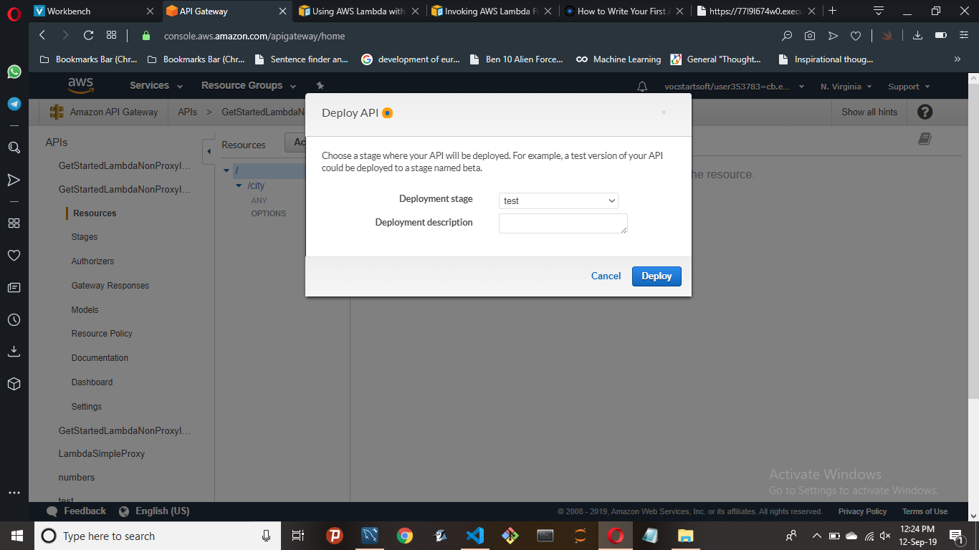

1. Once you deploy, you get an address for the GET method. Go to the **Stages** tab and go to **GET**  method

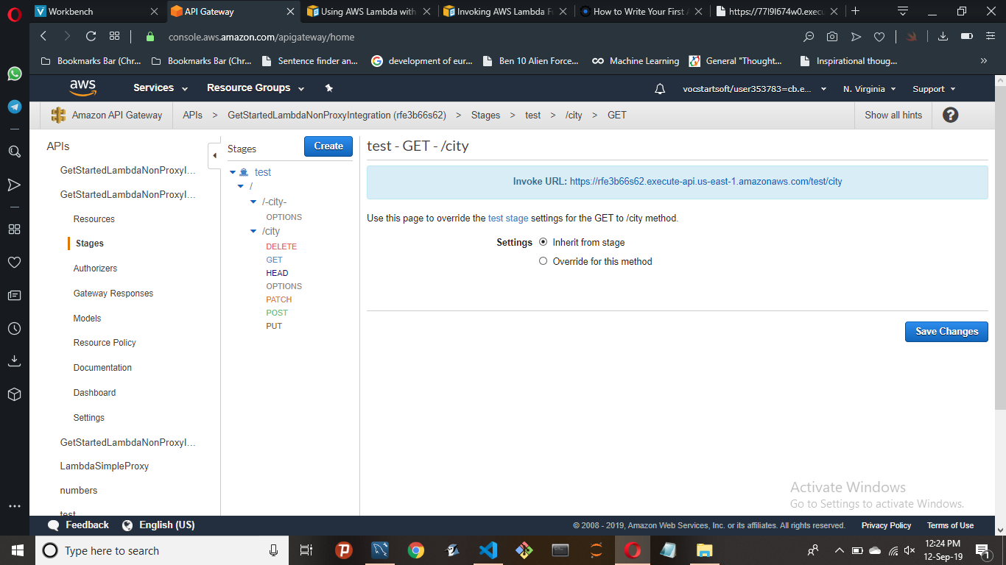

1. Now, paste this URL in the Form action of your HTML code
2. The code is ready to go for deployment. But, before that putting the entire code in S3 bucket gives you a domain to access from anywhere. So follow the below steps for configuration of S3 bucket. Now, create your S3 bucket and go to **Permissions** tab

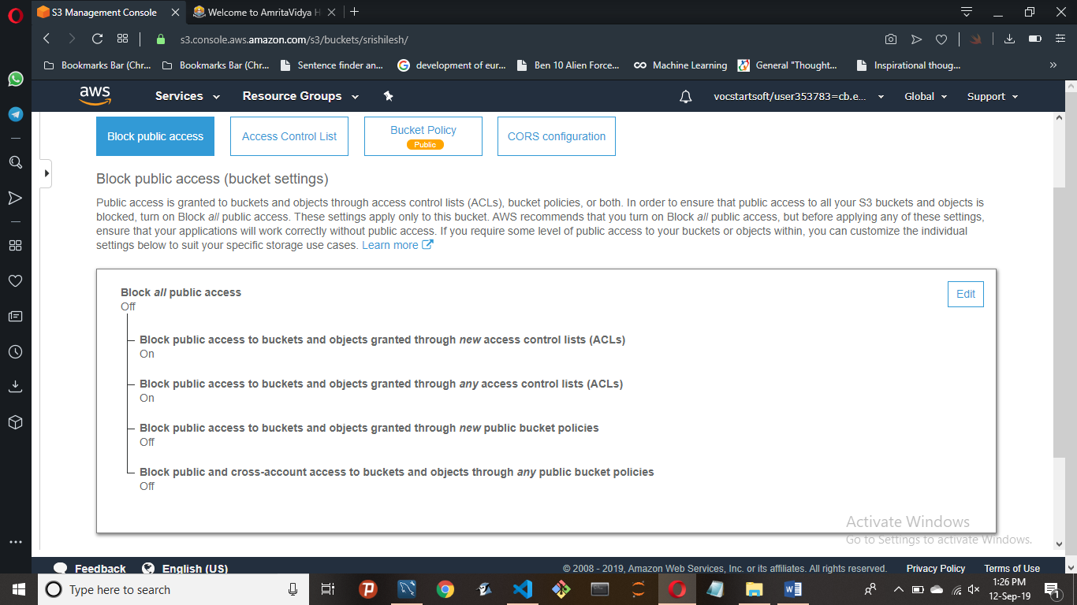

1. After giving access to the public, go to **Bucket Policy** and type the following

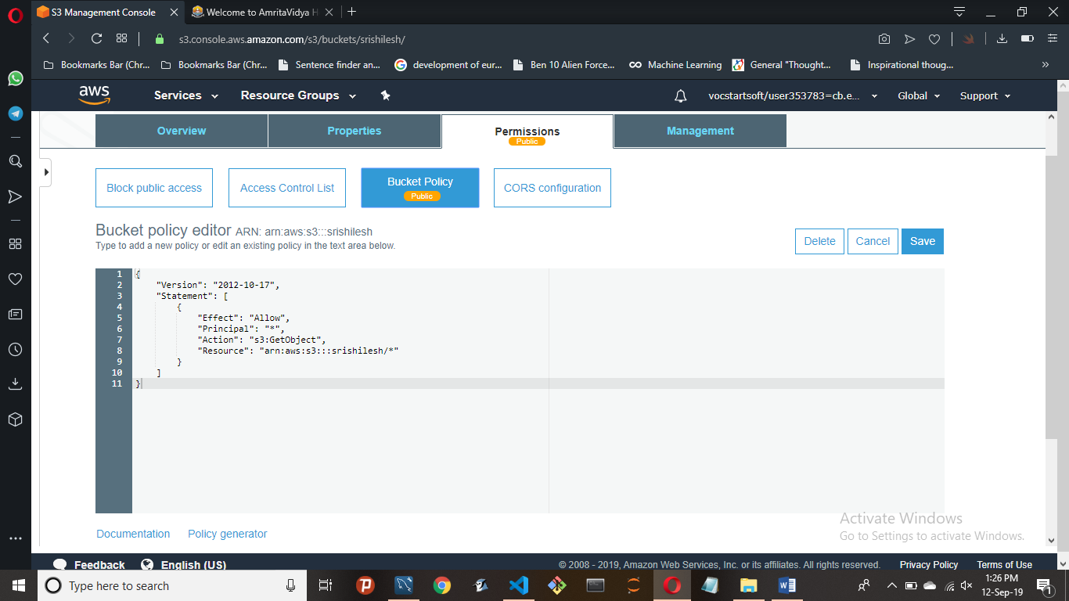

1. Now, it is ready to be deployed as a static website

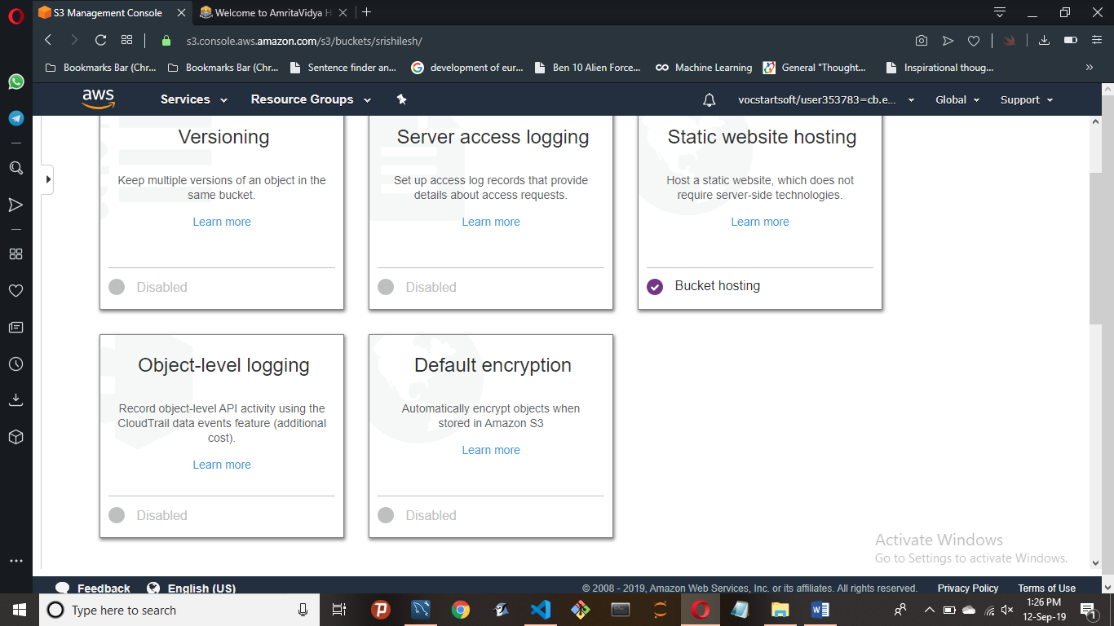

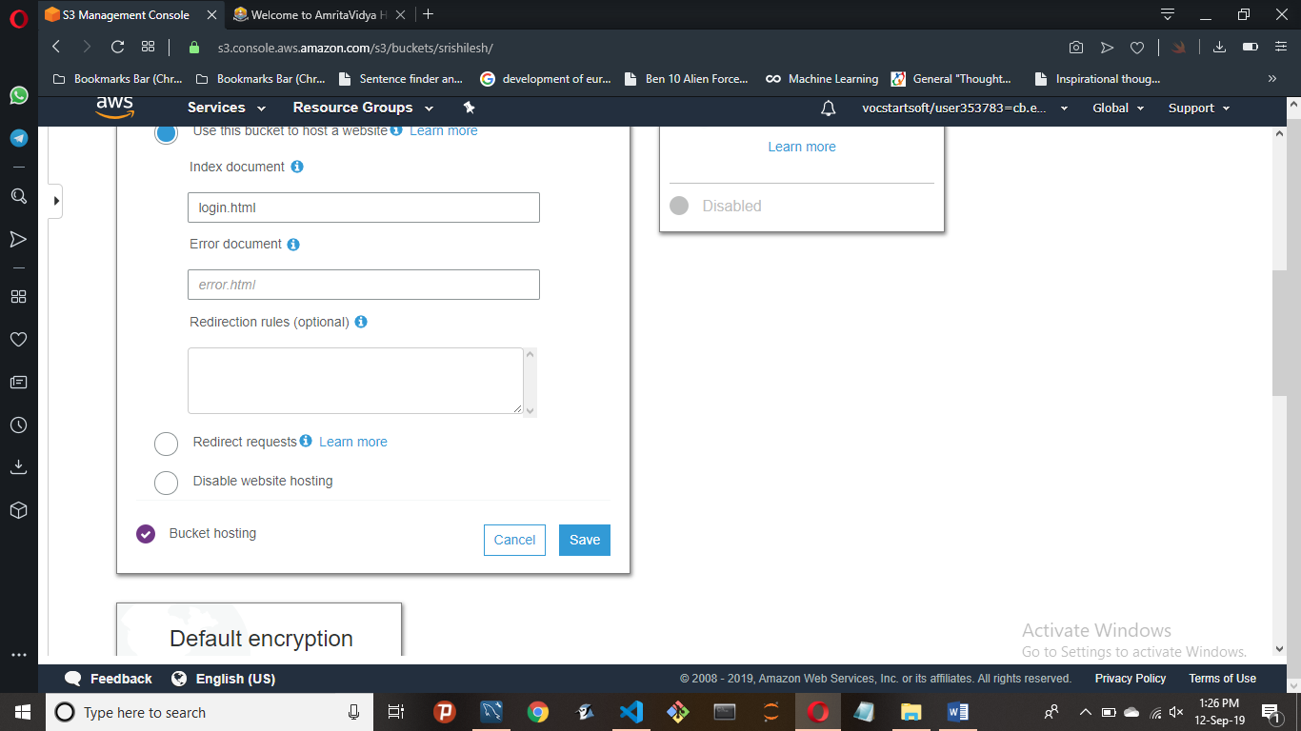

You will get the address of your bucket. Now, upload the HTML file into the bucket and access it from the domain address. Your static website is ready to go.